University of Kentucky NLM Alternative Spring Break Experience: A Guide

Introduction

About the Author
My name is Ariah Long and I am an Associate Fellow for the 2023-2024 cycle. I came into the Fellowship interested in student engagement and outreach initiatives. As such, I decided to coordinate the Alternative Spring Break Program for MLIS students at the University of Kentucky. The program was originally led by the Associate Fellow Coordinator.

Context
The National Library of Medicine (NLM) has been leading the Alternative Spring Break (ASB) program for University of Kentucky library students pursuing their Master’s degree in Library and Information Sciences since 2012. University of Michigan and University of Illinois have also participated in the Alternative Spring Break. Up to five participants typically embark on the experience.
The program aims to:
- Give students a glimpse into NLM
- Network
- Allow students to work on a relevant project to enhance their professional experience
- Learn about medical librarianship

What’s in this guide?
This guide provides information for NLM staff to host students for an Alternative Spring Break program:
- Process breakdown with timeline
- Example email templates (in italics)
- Key contacts

Call for Projects
As the Alternative Spring Break coordinator, it is your responsibility to curate projects for the student candidates to choose from. Therefore, the first step for this project is to send out a call for projects. This involves outreach to individuals within NLM to seek out relevant projects.
Major requirements for Alternative Spring Break projects are listed below:
- Must be be able to be completed within one week’s time (30 hours)
- The project must be doable on a personal laptop (students will not have access to NIH system)
You are looking to secure up to 4 or 5 projects so that students have a variety to apply for. Individuals across NLM may contact you to confirm or understand details of the program. You can direct people to submit their projects into the job jar or directly to your email. Once you solidify the project options, you will send the full project descriptions to University of Kentucky representative (Ashley DeWitt). They will coordinate the student application process on their end.
Tip: Check out the job jar for unchosen projects. Oftentimes, individuals across NLM submit projects for Associate Fellows, but not all of them are chosen. Yet, these are people who already have a project developed a and are looking for assistance. Reaching out to these project sponsors to see if they would be able and willing to configure their project to fit the requirements of the Alternative Spring Break.

Call for Projects: Example Email to LO

Hello everyone,
OET/LO will be virtually hosting University of Kentucky library science students for an Alternative Spring Break the week of March 11th. Kathel Dunn has coordinated the experience in the past, but I am excited to be leading it for 2024.
We are welcoming 4-6 projects of about 30 hours for the students to work on as they will remotely participate from March 11th - March 15th (9am-5pm). Please note that you would need to be available during this week to participate in a kick-off meeting and meetings with the student who chooses your project. Also, please keep in mind that students will not have access to the NIH network, so any project would need to be available to complete on a personal laptop.
If you are interested in participating in this and submitting a project, please input your project details into the Job Jar (located on the NIH Sharepoint) by filling in all the fields (i.e. Description, Goal/Key Deliverable, Skills Needed, Project Keywords, Expected Benefit to NLM). When submitting your project, please write that it is for the Alternative Spring Break within the description.
If you have a project that could be consolidated into a one-week experience for these students, please submit it to the Job Jar by Thursday, October 12th; I would greatly appreciate it. You would receive applications from interested students by mid-November, and then if everything is a match, we would host the students (virtually) from March 11 – 15, 2024.
If you have any questions, please feel free to reach out to me.

Call for Projects: Example Email to a Previous Job Jar Submitter

Hello ____________,

Thank you so much for proposing the project [INSERT NAME OF PROJECT THEY SUBMITTED] to the job jar. Although none of the current Associate Fellows selected your project, I wanted to present the option of making this project available to University of Kentucky library science students participating in our Alternative Spring Break experience.
We welcome projects of about 30 hours for the students to work on. If your project could be consolidated into a one-week experience for these students, I would need to know if you are interested by October 12th; I would appreciate it. Also, please keep in mind that students will not have access to the NIH network, so any project would need to be available to complete on a personal laptop.
You would receive applications from interested students by mid-November, and then if everything is a match, we would host the students (virtually) from March 11 – 15, 2024.
If you have any questions, please feel free to reach out.

Coordinating Project Placements
Ashley DeWitt has been the main representative for the UK LIS students doing the Alternative Spring Break program at NLM. She will be your main contact person for any questions you may have regarding logistics. After you have provided her with the project descriptions, she will send you the student applications.
Students apply for a specific project based on the description provided. Once you have their applications, it is up to you to coordinate their placement. This involves reaching out to project sponsors to provide them with the applications. If there are multiple applicants for one project, the project sponsor may choose the applicant best suited for the project. For some projects, it is appropriate to have two students work on it if the project sponsor is okay with that. Provide the project sponsor a deadline in which you would need a decision by.

Connecting with Students
It is important to understand participating students’ needs, wants, and goals out of the program as it will help you indicate how you will coordinate their week. Once placements are solidified, it is helpful to get a message out to them directly asking what they are looking to gain from the experience.
Early January is an ideal time to do this, as you will need to embark on the paperwork process with them shortly after. You can find the students’ email addresses in their application materials and either send out individual emails or use the blind copy (bcc) feature. Below is a sample email to introduce yourself as the coordinator and ask them some initial questions.
Key notes for introductory email include:
- Ensuring sure they are aware of the schedule and potential time zone differences
- Confirming contact information is always good practice in coordination projects
- Getting to know them by telling them about yourself first
- Providing links and clear dates
Hello,
Happy New Year! Thank you for applying to the Alternative Spring Break Program. NLM is excited to have you! While we have several weeks until Spring Break (March 11th – 15th), I wanted to reach out to introduce myself. My name is Ariah Long and I am Associate Fellow at the NLM. I will be leading the ASB Program this year. Since I’ve read a bit about you through your application, I’ve linked my bio in the previous sentence 😊.
Below I have some information/requests:
- Your hours for the week will be 9am-5pm with a lunch break. Please let me know your time zone! If you need an alternative schedule for the week, let me know and we can work something out.
- Please confirm your contact information with me. I will be planning some meetings and looking to connect you with your project sponsors, so I want to confirm that this is the best email address.
- Please let me know if you have any specific interests within librarianship (e.g. policy, digital collections, PubMed). I can look to arrange informational meetings with individuals working in areas of interests.
  - Check out NLM’s website, blog, History of Medicine’s blog (Circulating Now) for ideas!

Please look out for another email from me with requested paperwork. I will need those materials from you by Friday, February 2nd.
If you have any questions at this time, please let me know. I am looking forward to meeting you and having a great experience!

Processing Students
After placements are confirmed, and students accept their positions, you will want to contact Amy Powers (Ethics Specialist) to obtain the Special Volunteer paperwork requirements. In recent years, she has provided a simple check list that will direct you to the PDF forms you can send to the students.
Contact students to begin paperwork process and provide a clear date in which you would need the materials by. Once you receive all of the information from each student, you contact your Administrative Officer (Tonia Justice) and they will advise you through the internal routing process. See an example email below for providing students with the necessary information and paperwork.
Hi,
We’re delighted that you’ll join us remotely for your Alternative Spring Break March 11 – 15, 2024. We have paperwork we need to fill out first! It would be most helpful if you could respond with the needed information by Friday, February 2nd. The forms are:
- NIH Form 590-2 (attached). I ask each of you to fill out this form, sign, and send back to me by email. For the start / end dates put March 11 to March 15; number of hours is 40.
- NIH Form 590 has a lot of PII (personally identifiable information), so rather than email the form back and forth, I would ask that we set up a Zoom video call so that you can verbally tell me the following information:
  - Your city and country of birth
  - Current citizenship
  - Name and address of your current employer
  - Name of your health insurer
  - I will also need a scanned copy (front and back) of your health insurance card. Please send that by secure email.
- CV and bibliography

Please email me individually so we can coordinate a 30-minute chat in the coming weeks to have a meet and greet and go over the NIH Form 590.

Coordinating the Week
The experience typically takes place in mid-March. As such, you will likely want to start coordinating the week several weeks in advanced to solidify schedules. This may involve reaching out to individuals in different NLM units. You can provide a wide variety of structured meetings for the students such as:
- A kickoff meeting with all project sponsors on the first day (highly recommended)
- One-on-one meetings with you and the student(s) mid-week, or a full group meeting to check in
- Informational sessions with different NLM units
- Time at the end of the week to present
You will want to be in contact with the students, project sponsors, and potentially individuals in other departments during this coordination process. Ensure that your schedule is open during the Alternative Spring Break week as well. You may want to connect your students with their project sponsors at least a week before the actual week of spring break.

Spring break
When the week of spring break arrives, it is helpful to have a kickoff meeting with students and project sponsors if schedules allow.
Outside of that, make sure you are checking your email for any questions that may come through from the students as you are their main contact for logistics during their experience. You may want to check in with them throughout the week to ensure things are going smoothly. Other than that, the students will largely be working with their project sponsors throughout the week. When the week is completed, an evaluation is usually sent out from Ashley DeWitt.
Overall, committing to leading the Alternative Spring Break experience involves coordination, communication, and organizational skills. This is a great opportunity for those looking to connect with students.

Appendix

Schedule for the week of Spring Break
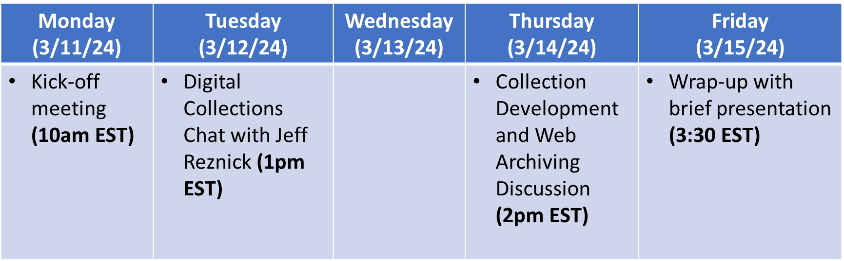

Student Reflections

See student reflections on their Alternative Spring Break experience on the University of Kentucky School of Information Science website. See Zoë Blackwell, Lauren Savage, and Lydia Tchividjian’s reflections under the 2024 dropdown menu.

