Portraits of Katharine Minola

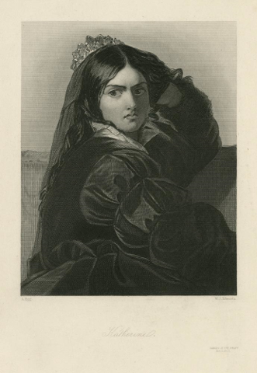

David Bogue, Angry face of Katharine Minola, 1847 Courtesy Folger Shakespeare Library

Shakespeare depicts the full range of humoralism in his dramatic characters. An excess of the hot, dry emotion of choler, or yellow bile, produced an angry disposition. Choler is valuable in great warriors but in the domestic world of romantic comedy, anger—especially the anger of women—represents a social problem for Shakespeare’s age, which calls for strong therapeutic intervention.

How to manage female anger is the central question of Taming of the Shrew. Both protagonists, Kate and Petruchio, are identified as choleric by nature, and Petruchio’s behavior in the play is widely seen as eccentric and disruptive. Yet, it becomes Petruchio’s job as husband to tame his shrewish wife and make her “a Kate conformable as other household Kates.”

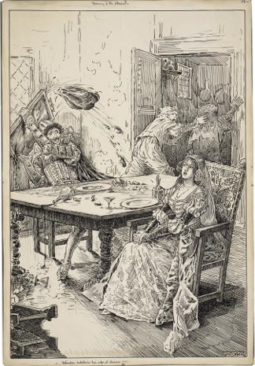

Louis Rhead, Petruchio entertains his wife at dinner, c. 1918
Courtesy Folger Shakespeare Library

Petruchio denies his wife dinner, claiming that roasted meat is too hot and dry for her nature. He deprives her of the pleasure of new clothes and of female companionship. All these deprivations have the effect of wearing her out, both physically and emotionally, until by the end of the play she is willing to submit to his humor, no matter what it might be.

