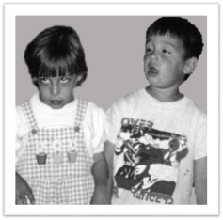  Alexis & Noah’s Case | NOTES
Phenotype
Preliminary Diagnosis
Genetic Variation(s)
Laboratory Assertion(s)
Variant Information:
- Asserted interpretation listed in ClinVar
- HGVS names from ClinVar
- Is population data available in dbSNP?
Gene Information in
NCBI Gene:
- Symbol and Name
- Gene Summary

- Tissue Expression information

- Gene Ontology information
Ultimate Impacted Biomolecule based on:
- GDV to view the chromosome and gene region
- RefSeqGene Graphics view of gene region and transcript(s)

- RefSeq Protein Graphics view of protein and domains

- CDD or iCn3D to view a structure, as needed
Proposed Molecular Mechanism of Variant Impact
How does this relate back to the phenotype (symptoms/clinical features & diagnosis)?

